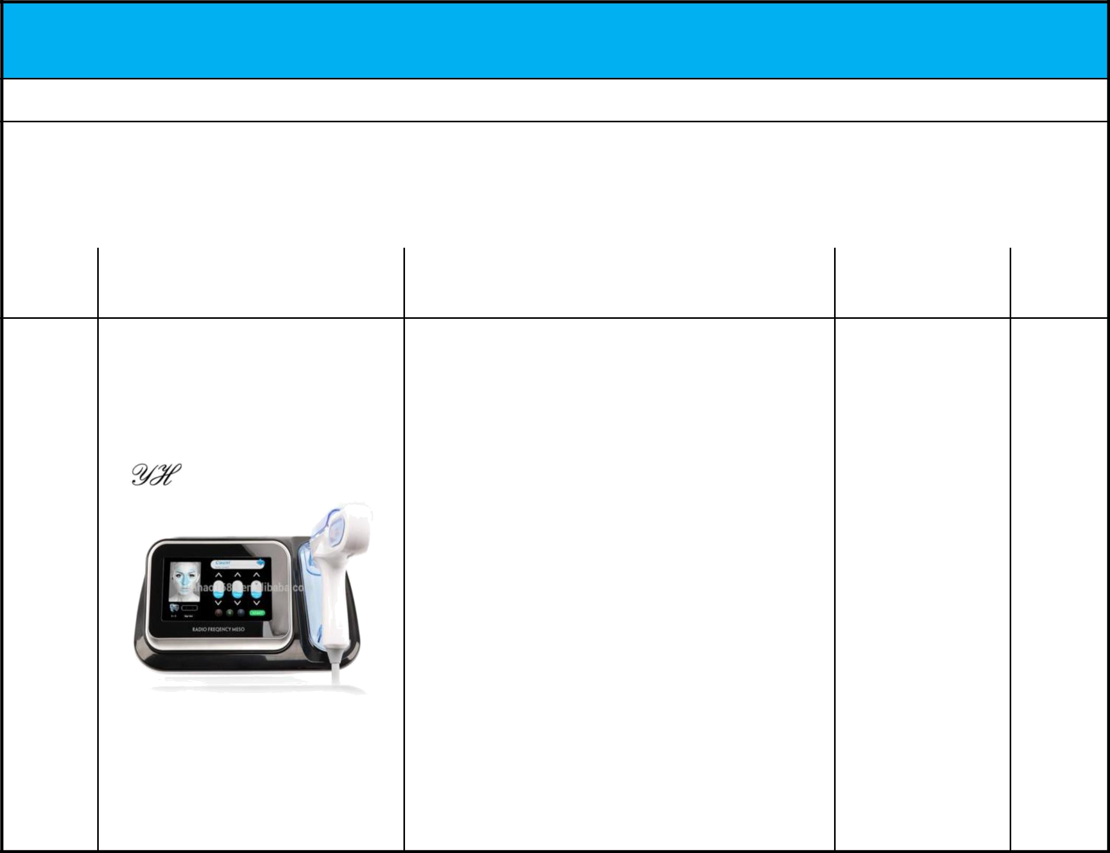
RAMCO ADVANCED COMPANY.

Add.: Kuwait, Farwaniya, Habib menawer Street, Qannas Saud Alnemran Complex,2nd Floor, Office 5.

 |  |  |  | email: ahmed@ramcoadvanced.com
 | Validity: |  | Date:
 | Model | Picture | Specifications | Functions

 | *Type: Mesotherapy Gun
 | *Certification: CE
 | *Place of Origin: Daily Need - korea
 | *Feature: Moisturizer, Skin Rejuvenation, Wrinkle
 | Remover | 1.Moisturizer
 | *Voltage: AC 110V-220V | 1.Moisturizer
 | *Voltage: AC 110V-220V | 2.Skin Rejuvenation
 | *Radio Frequency: 4Hz | 2.Skin Rejuvenation
 | *Radio Frequency: 4Hz | 3.Wrinkle Remover
 | *Input power: DC 12V | 3.Wrinkle Remover
 | *Package Size: 34 x34 x44cm
 | *Weight: 5.2Kg
 | *Photon Light Color: Red, Green, Blue
 | *Microcrystallines head: 3 x 3, 5.5 x 5.5, 8.8 x 8.8
 | *Style: Portable

