Pure 24 K Gold Beauty Bar

The 6,000 times per minute micro vibration, gives the facial muscle a right amount of stimulation to achieve a firming and tightening skin. It can also reduce wrinkles around eyes, lips, forehead and neck, instantly reshape the face contour to reveal your youthful look and energy!
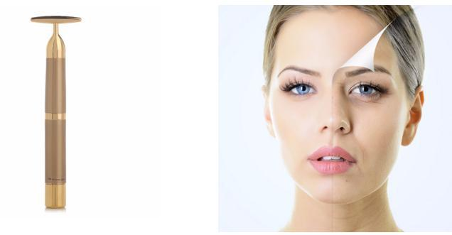

2-3 minutes per day

easily obtain the firm and radiant skin you always dreamed of !
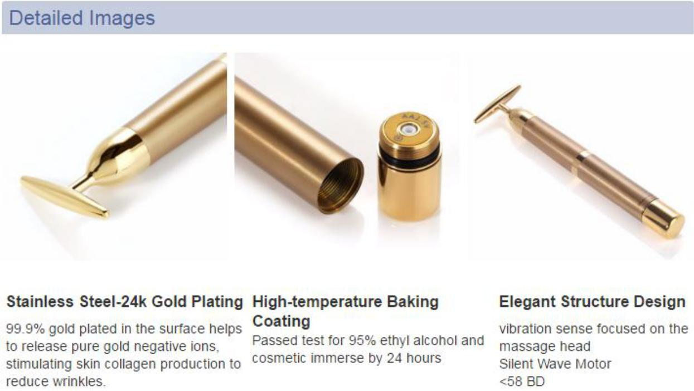
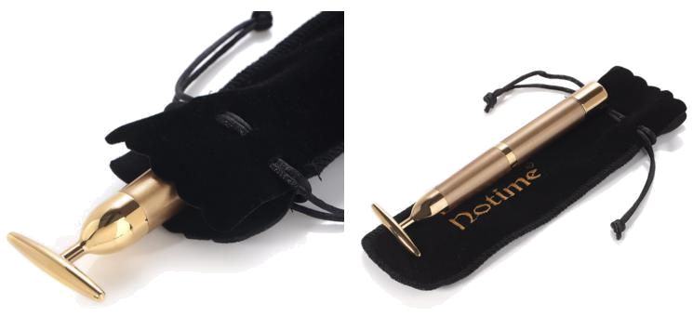

6000 times/mins micro vibration gives facial skin powerful and fast lifting to achieve a good-looking V-shaped face.

Perfect for Lymphatic detox, skin lifting, face slimming, wrinkle removing, skin lightening and tender skin, anti-aging.
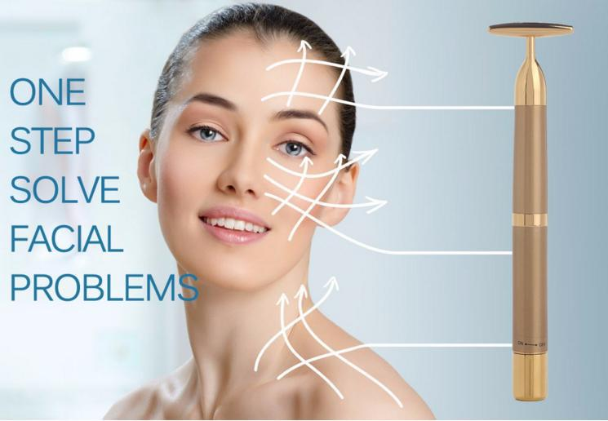

01: Lymphatic Detox Therapy

T-shape head can emit micro-current to stimulate facial cells, thus balance the skin potential, and get through facial lymph circulation, enhance function low cell's protein synthesis and nutrient penetration.Promote the elimination of the waste, eliminate redundant toxins.

02: Lifting

The voltage of one normal cell is 0.06-0.07 V, resulting from reasons such as air pollution and working press, the cell voltage might reduce to 0.02-0.03 V, so the skin would be flabby. Beauty bar can activate cell activity, enhance cell energy, finally achieve the function of lifting.

03: Wrinkle Removing

Emit pure gold negative ions. Gold ions can stimulate dermal level to emit more collagen, fill up the lost or absorb collagen.

04: Slimming Face

Stimulate blood circulation rapidly, and the temperature below the skin would rise rapidly, thus activates cell activity, tighten facial muscle, removes wrinkle and unnecessary fat.

05: Lightening and Tender Skin

Give cells with micro current, activate cells activity, enhance function low cells' protein synthesis and oxidation ion exchange and nutrient penetration. Improves facial blood circulation, minimize pore white and tender your skin.

06: Anti-aging / Rejuvenation

Gold ions enter into dermal level of skin, echo with the positive ions in human body, eliminate the free radicals in cells, promote blood circulation get better, increase metabolism, make your skin tissue activate from inner body, wake up your skin and realize rejuvenation.
